**Login Page**

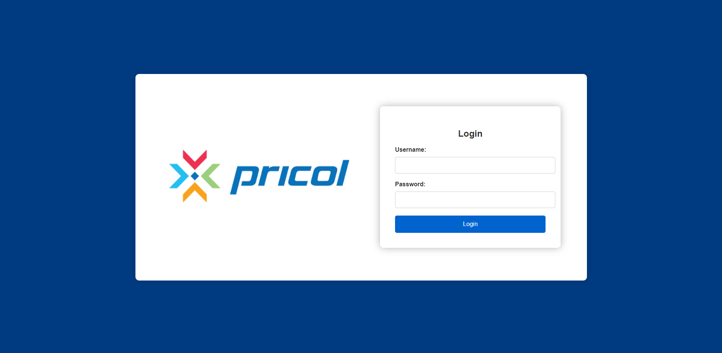  
**For Admin Access:**

* Username: Admin1
* Password: Admin@1

**For User Access:**

* Username: User1
* Password: User@1

**Dashboard / Home Page**

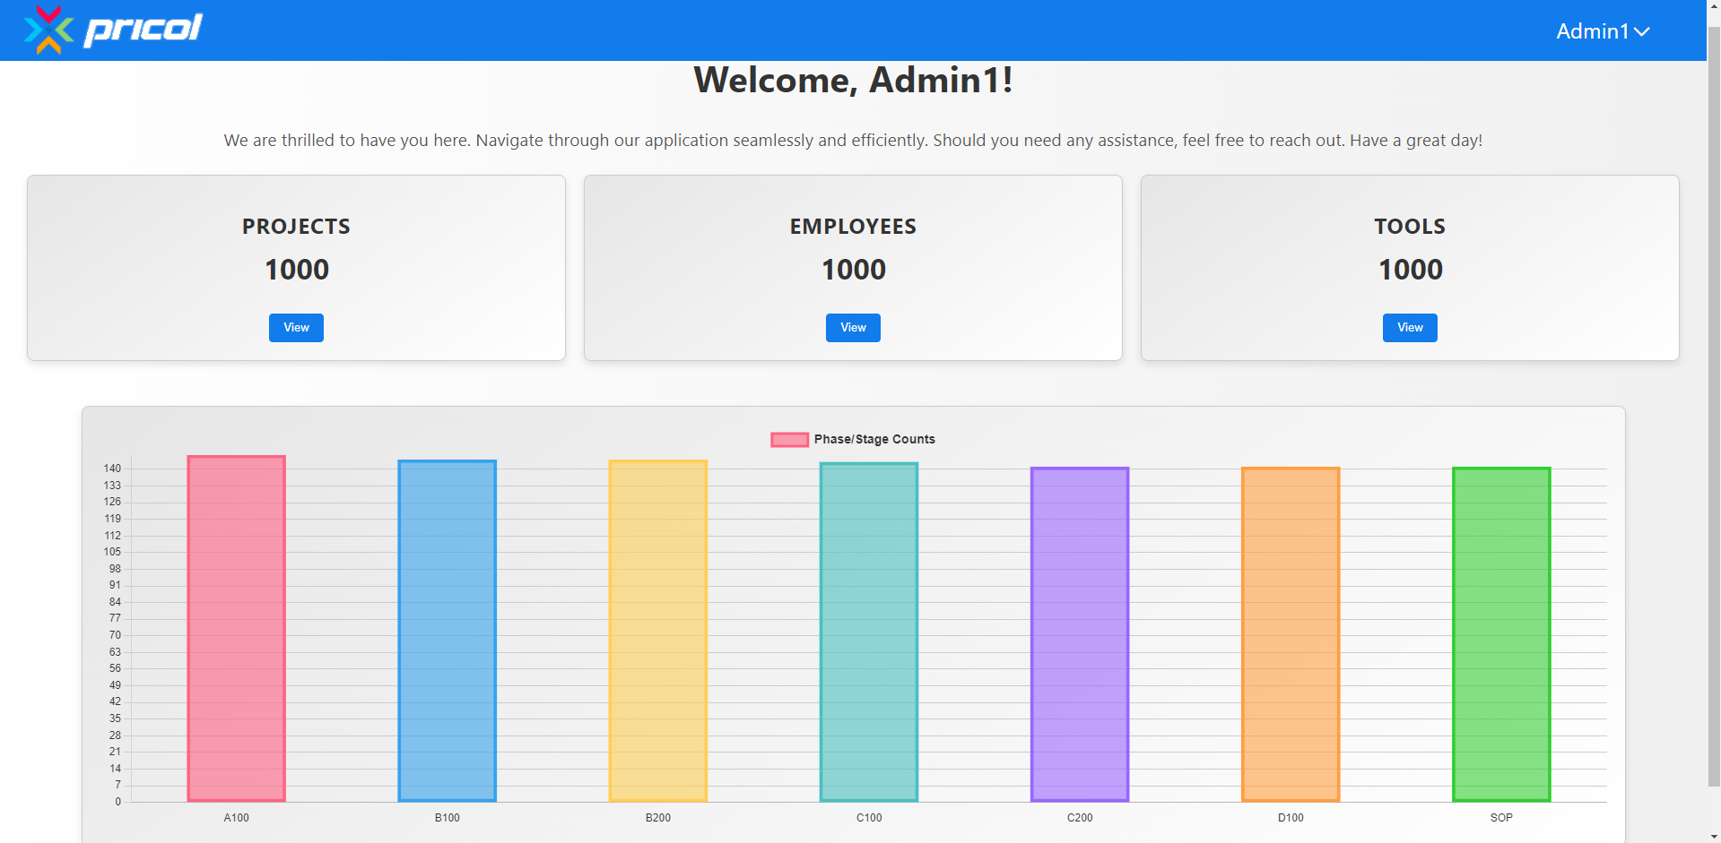

**Hover Over Bars:** Hover on the bar chart to see the exact numbers for each phase/stage.

**Navigation Buttons:** Press the buttons below "Project," "Employees," or "Tool" to view the respective tables as per your choice.

**Logout/Register:** Click the username at the top right corner to log out or register a new user.

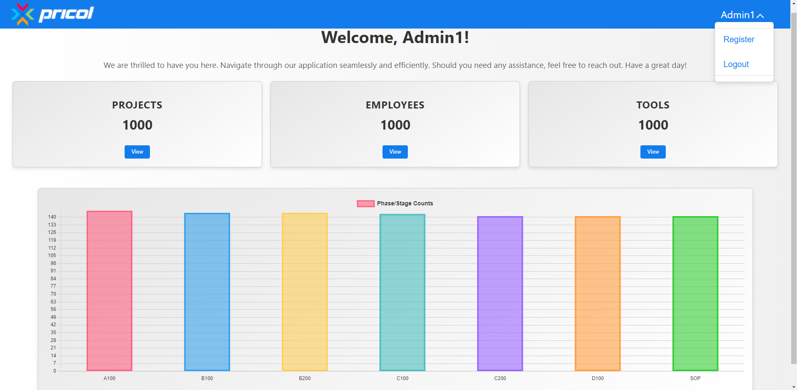

**Note:** The register option is only available to admin users, not regular users.

**Register Page**

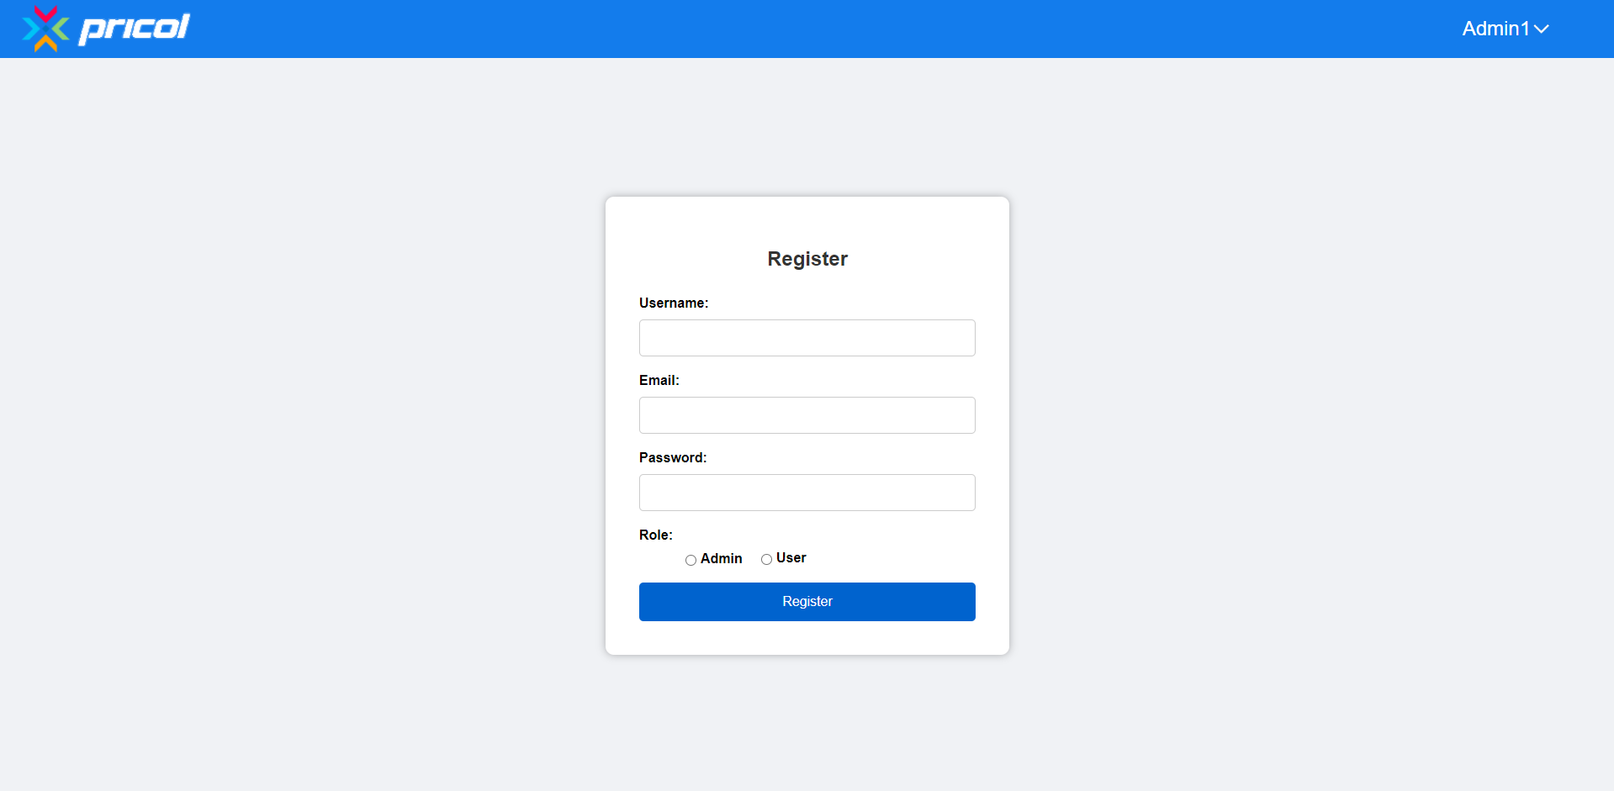

**Create Users:** You can create a new admin or regular user.

* Only admins have the rights to create new users.

### Project Tracker Page

**Dashboard Navigation:**

* Click any "View" button as needed.

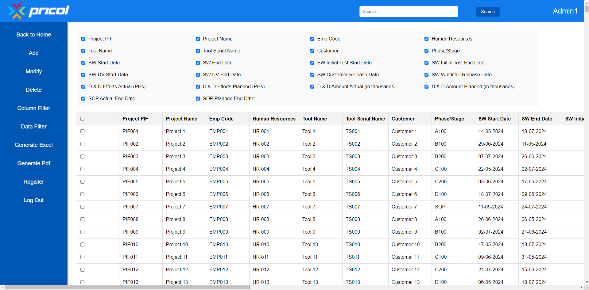

**Adding a New Project:**

* Click the "Add" button in the left navbar.
* Fill in the details and click "Add New Data."

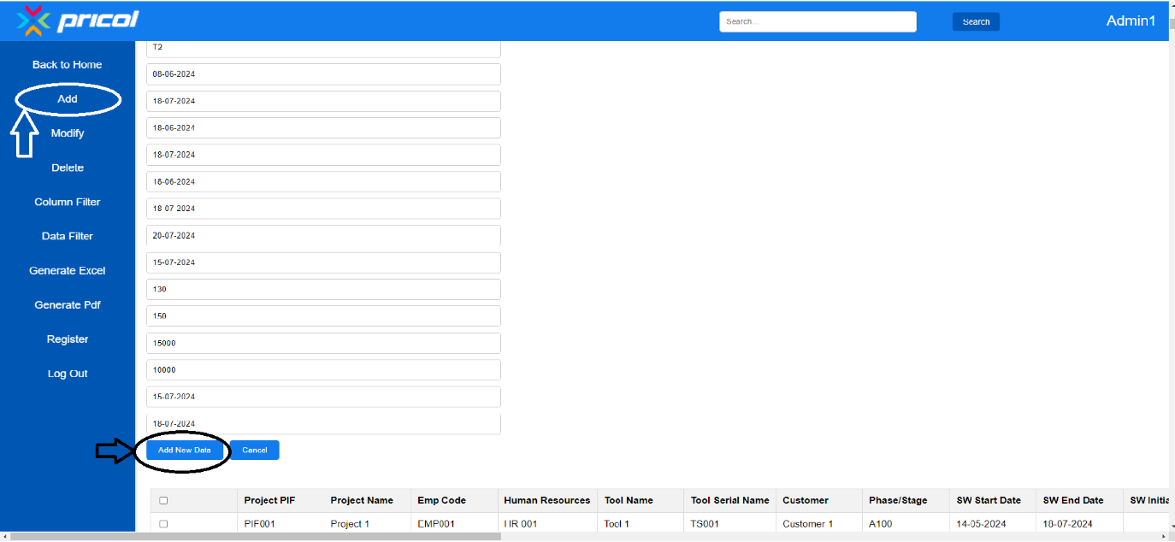

**Modifying Data:**

* Select the row you want to update.
* Click the "Modify" button, make the required changes, and press "Modify Data."

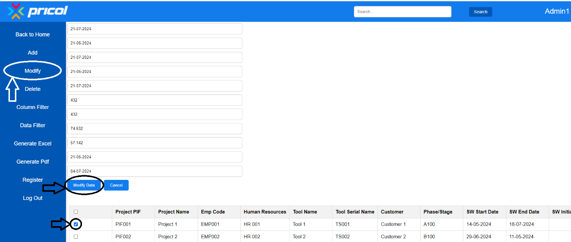

**Deleting Data:**

* Select one or more rows you want to delete.
* Click the "Delete" button on the navbar.

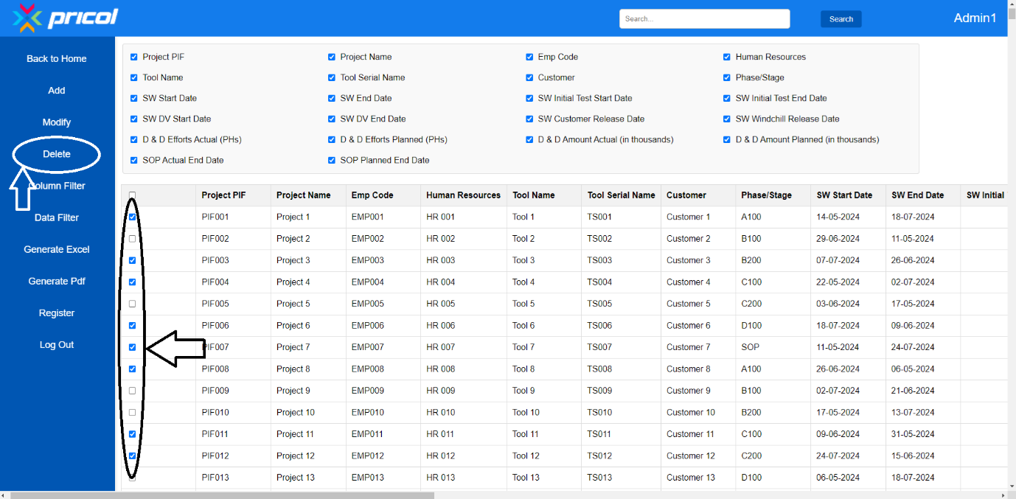

### Column and Data Filters

**Column Filter:**

* To filter out columns, click the column filter option above the table.
* Uncheck the boxes of the columns you don’t need.

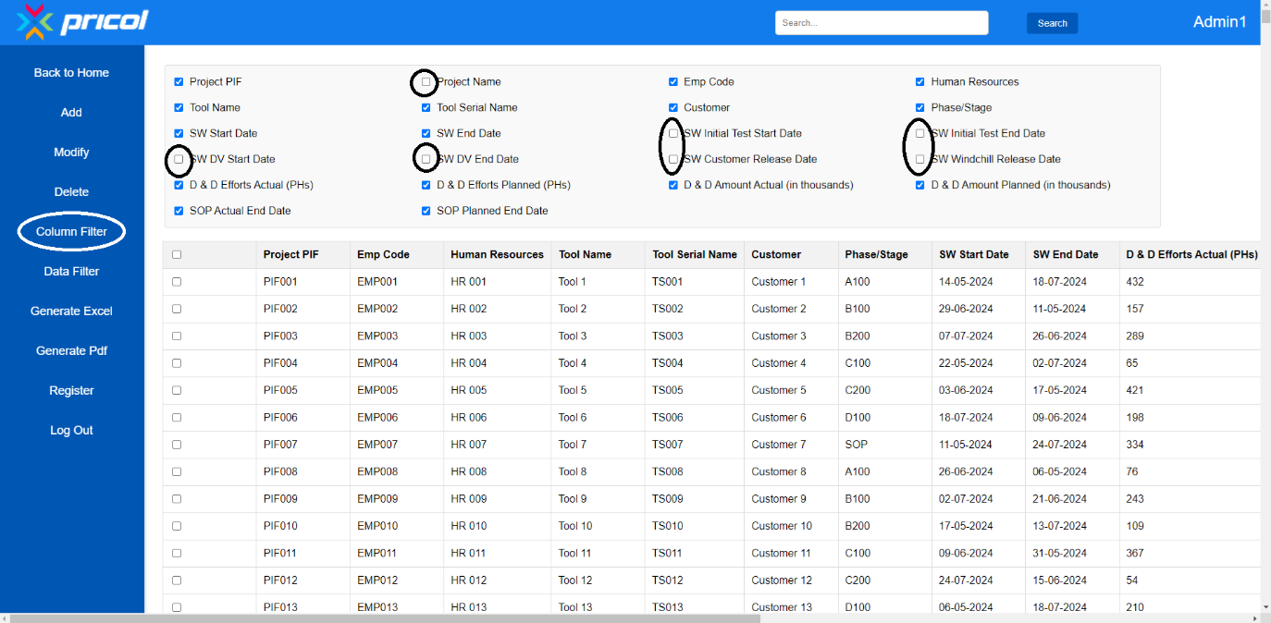

**Data Filter:**

* To filter rows, click the "Data Filter" button.
* Select the criteria from each column to filter the data.

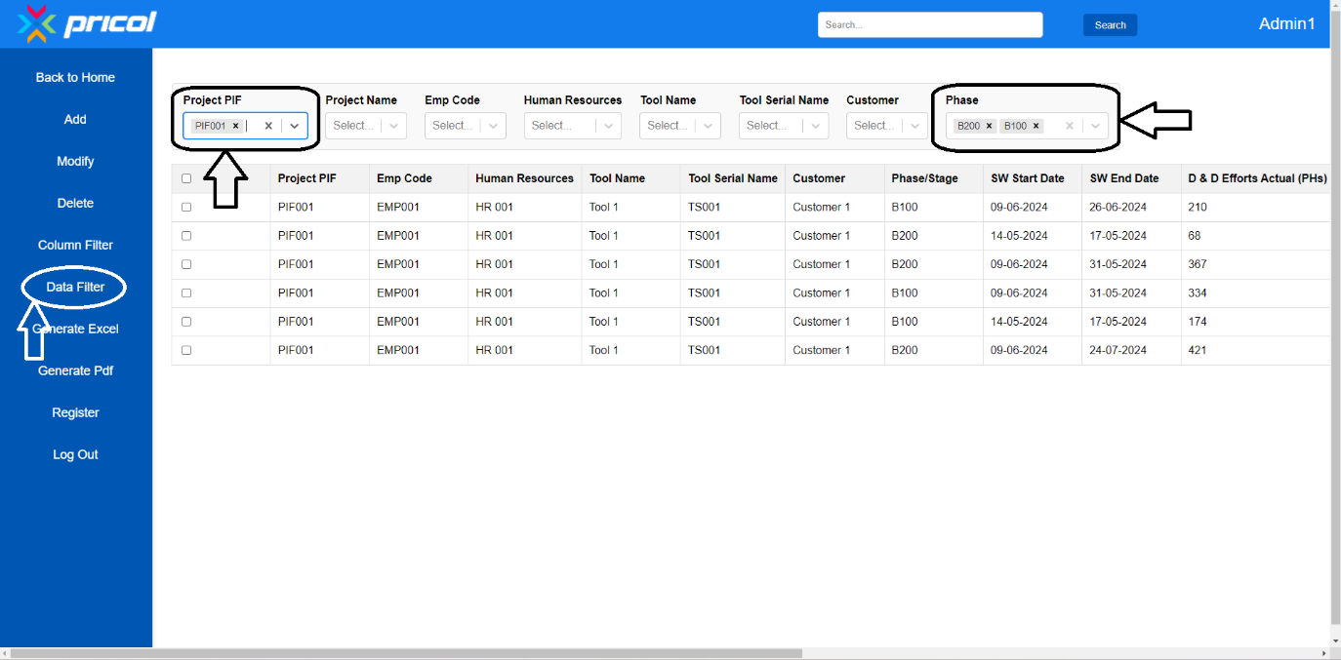

### Generating Reports

**Generate Excel or PDF:**

* First, filter the columns and rows as needed.
* Click "Generate Excel" or "Generate PDF."
* You can also select specific rows by clicking the checkboxes.

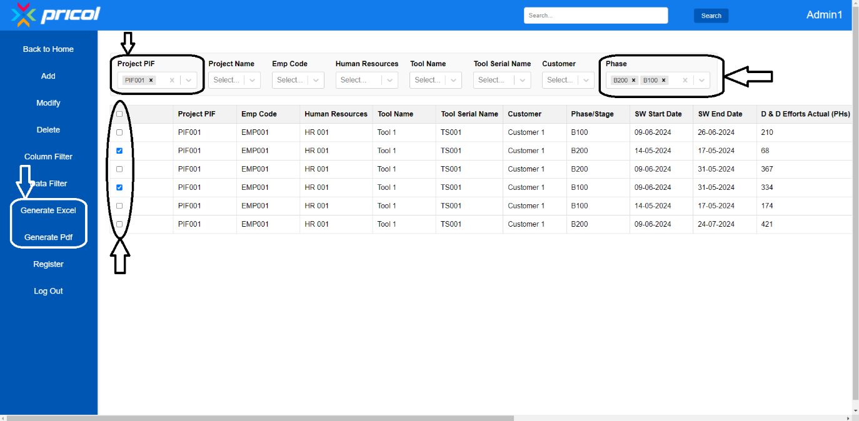

**Search Function**

**Search Box and Button:**

* Type your search query in the search box.
* You can also use the data filter for easier searching.
* After typing, click the "Search" button; it will highlight the text you are searching for.

